Postal Life Insurance

Department of Post

Software Requirements Specification (SRS)/ Functional Requirements Specification (FRS)
  - Policy Issue

INTERNAL APPROVAL FORM

Project Name: Policy Issue
Version: 1.0
Submitted on:
 | Name | Date
Approved By:
Reviewed By:
Prepared By:

VERSION CONTROL LOG
Version | Date | Prepared By | Remarks
1

Table of Contents

1. Executive Summary 4
2. Project Scope 4
3. Business Requirements 4
3.1 Client Creation 4
3.2 Proposal Management 6
3.3 Policy Issue 7
3.4 Document Scanning & Management 9
3.5 Approval Workflow 11
3.6 Receipt and Printing Management 11
3.7 Policy Bond 11
4. Functional Requirements/ Business Rules 12
1.1 Policy Issue- Without Aadhar Page 15
1.2 Policy Issue- With Aadhar Page 30
1.3 Proposal Creation- Using File Upload 36
5. Wireframe 38
5.1 Policy Issue- without Aadhar Page 38
5.2 Policy Issue- with Aadhar Page 40
5.3 Proposal Creation- Using File Upload 44
5. Test Case 45
6. Appendices 47

1. Executive Summary
To define the requirements for implementing the New Business Policy Issue process in the Insurance Management System (IMS) for India Post PLI. This process will enable seamless onboarding of new policyholders, ensuring compliance, automation, and integration with existing systems.

2. Project Scope
This module will support:
- Client creation
- Proposal management
- Document scanning and management
- Policy issue process (manual, digital via Aadhar, and bulk upload)
- Multi-level approvals (Data Entry at CPC, Quality Reviewer, Approver)
- Receipt and printing management
- Policy bond issuance

3. Business Requirements

3.1 Client Creation
Requirement ID | Requirement
FS_NB_001 | The system should capture the basic details during customer onboarding through direct workflow-based integration with the sourcing applications such as Customer Portal, mobility solution, and partner channels (including but not limited to).
FS_NB_002 | The system should be able to create a unique customer ID applicable to all types of policies in DoP. There should be validation to avoid the creation of duplicates. Customer IDs should be created during policy issuance workflow.
FS_NB_003 | The system should always create a client against any association including but not limited to customers, agents, products, and any other third parties. Some of the fields used for creating a client (including but not limited to)  a. First, Middle & Last Name  b. Date of Birth  c. Gender  d. Email ID  e. Phone Number  f. Address  g. Aadhar Number (Optional)  h. PAN Number (Mandatory if premium is above 50,000)  i. Nationality  j. Country of Residence  k. Any other fields in the future  l. eIA ID  All the above fields should be available in UI & have field-level validations.
FS_NB_004 | The system should be able to deduplicate and flag customers without hampering the customer creation process flow or slowing down the system. The system should facilitate multiple configurations & parameterization through the front end for setting up the deduplication process.
FS_NB_005 | The system should have the capability to integrate with the latest technology such as OCR for capturing the data entered forms.
FS_NB_006 | The system should provide rule-driven validations for the data fields (Example: Pincode & State mapping)
FS_NB_007 | The system should highlight any fields for which the customer data entered is outside the boundary conditions set for that specific field which should be configurable.
FS_NB_008 | The system should handle page/module-level validations during the proposal quality check.
FS_NB_009 | The system should integrate with different channels such as web portals, mobility solutions, and partner channels such as Common Service Centre (including but not limited to) to capture customer information and undertake validations as per business rules.
FS_NB_010 | The system should auto-trigger any additional requirements for onboarding a customer.
FS_NB_011 | The system should have the facility to capture and update policyholder details, Life Assured details, Premium payer's details, Nominee’s details, and additional parameters separately as per DoP's requirement.
FS_NB_012 | System to capture customer bank details as part of account creation (Example: Cancelled cheque can be used to capture bank account information, Account with Post Office Savings & IPPBDoP)
FS_NB_013 | The system should maintain the customer ECS mandates, Standing Instruction (SI), and NACH details.
FS_NB_014 | The system should validate various key customer KYC documents like Driving License, Birth Certificate, Bank details, PAN, Aadhar, Digilocker, and with other systems through web service integration (including but not limited to)
FS_NB_015 | The system should create separate customers along with different customer IDs as two Life Assured in case of Joint life scenarios.
FS_NB_016 | The system should perform an AML check for blacklisted customers and agents before creating a customer entry into the system through third-party integration such as (including but not limited to) IRDAI, NSDL, UIDAI, DoP AML repository, integration, etc.
FS_NB_017 | The system should have the facility to capture and update customer details basis the c-KYC/e-KYC-based authentication (Through Integration with UIDAI, NSDL, Digi locker, integration (including but not limited to) provided by the customer.
FS_NB_018 | The system should have levels of KYC basis low and high-risk customer type, product offered, SA opted and other parameters and should be compliant with the latest PMLA rules.
FS_NB_019 | The system should have a flag for KYC completeness and once the KYC process is complete, the flag should automatically get activated.
FS_NB_020 | The solution should be able to update personal data details during policy tenure by integrating real-time with other entities such as UIDAI, NSDL, and Digi locker, integration (including but not limited to).
FS_NB_021 | The system should be capable of configuring the customer ID sequencing number as per PLI or RPLI for new business (For Example: PLI Policies will start from 1 and RPLI will start from 5).
FS_NB_022 | The solution must have a provision to consume DoP GCIF (Global CIF) once the service to be consumed is available which will be a common Client ID for all DoP LOBs - Postal, Banking & Insurance.
FS_NB_023 | The system should create & configure riders as separate products along with creating service requests through the front end.
FS_NB_024 | The system should have the capability to integrate with IRDAI, validate eIA & capture required details as per IRDAI guidelines and regulations.
FS_NB_025 | The solution must capture collection & payment channels at the time of Customer creation (Example: Standing Instructions, POSB, eBanking, mobile-Banking, IPPBDoP, CSC, etc).

3.2 Proposal Management

Requirement ID | Requirement
FS_NB_026 | The system should be able to source policy from the following channels but not limited to these channels. Direct (Branch Walk-In), Agency, Web Portals, Mobile Application, POS.
FS_NB_027 | The system should capture the basic details entered for BI generation workflow and tag it with Proposal ID for future reference in the PAS.
FS_NB_028 | The system should be able to capture the customer details pre-populated from the quote generation module.
FS_NB_029 | The system should have the capability to integrate with third-party KYC services (Aadhar, NSDL), etc.
FS_NB_030 | The system should be able to validate the data from the images stored in the document management system with proposal data through OCR and ICR functionality.
FS_NB_031 | The system should be able to validate the data entry done by the operations team - all the field level and length validations should be built into the data entry platform.
FS_NB_032 | The system should populate the applicable product-specific quality check questions required for financial & medical u/w review.
FS_NB_033 | The system should perform a basic fraud analytic check at the proposal generation stage basis the customer details provided and previous customer data (if available). The system should trigger additional requirements.
FS_NB_034 | The system should trigger additional requirements in case some documents are attached under Non-standard proofs.
FS_NB_035 | The system should be able to display the proposal summary highlighting the most important fields including but not limited to - Name, DOB, Occupation, Sum Insured, and Premium details.
FS_NB_036 | The system should be integrated with the workflow system and status updates need to be provided to the respective advisor and customer.
FS_NB_037 | The system should be able to provide a return journey for the data entry person. Previously saved information should be retrieved and populated.
FS_NB_038 | The system should maintain workflow details in the workflow master and should maintain versions for auditing purposes.

3.3 Policy Issue

Requirement ID | Requirement
FS_NB_039 | The system should be able to generate data files in any format including but not limited to spool, CSV, etc. for generating the policy kit.
FS_NB_040 | The system should be able to create an electronic policy kit post-issuance through a registered email ID & send it through different modes such as Email, WhatsApp, SMS, etc.
FS_NB_041 | The solution can accept Proposals & issue Policies instantly for selected Product Types from selected Channels with authentication: Through eSign, Digital Sign, Digi Locker, Aadhaar, PAN, e-KYC/c-KYC, eIA for predetermined parameters including but not limited to premium factor, and sum assured.
FS_NB_042 | The system should be able to create a hyperlink to open the policy kit from the link. The hyperlink is available in Channels, Portals, Registered Email ID, etc.
FS_NB_043 | The system should be integrated with NSDL for capturing the e-Insurance Account Number (eIA) of customers used for storing policy documents belonging to various insurers.
FS_NB_044 | The system should update the policy details to EIA through XML, direct API-based updates as per requirements of eIA.
FS_NB_045 | The system should reserve the right of final Policy Issuance with DoP as the final approver in the maker-checker-approver process flow as per business rules.
FS_NB_046 | The system should be able to update the policy and customer-level data during the entire policy lifecycle such as issuance, servicing, claims, etc. system currently & in the future.
FS_NB_047 | The system should have the option to capture the assignee/appointee details, in case the nominee is minor as per business rules.
FS_NB_048 | The system should be able to capture the nominee's DOB and auto-calculate the minor status of the nominee.
FS_NB_049 | The system should have a provision to capture the relationship between the nominee and the proposer.
FS_NB_050 | The solution must support the Printing of Policy Documents in any Pre-Designed Format, A4 Sheets, etc. as per business requirements.
FS_NB_051 | System to capture the dispatch date and delivery date of policy document as a reverse feed by integrating with the postal module at DoP for tracking & managing the free look period once the customer acknowledges the policy kit
FS_NB_052 | The solution must populate the Freelook period in the core policy admin System. SMS & Email/inbox notification alerts should be sent to customers & agents. The freelook period should be shown in reports as per business requirements.
FS_NB_053 | System to provide reverse feed to various integrated portals and CRM for the status of the dispatched policy kit
FS_NB_054 | The system should have the capability to provide the Free look period applicable basis with the channel through which the policy was sourced & should be configurable through the front end.
FS_NB_055 | The system should refer to the dispatch management details either through physical post or sent through email for deciding on the Free Look period validity. The solution should be capable of integrating with other DoP & third-party solutions (TPA)
FS_NB_056 | The system should have role-level rights/exceptions to accept free-look cases outside the validity period as per business requirements.
FS_NB_057 | The system should generate a premium and tax refund accounting entry in case of Free Look Cancellation (FLC). GST will not be refunded along with other deductions such as Medical Practitioner fees, Stamp duty, etc. The rules should be parameterized & set through the front end.
FS_NB_058 | The system should generate refund receipts in FLC cases through the front end after deducting all Admin charges, Fees, etc.
FS_NB_059 | The system should provide the capability of bulk upload through the front end of customer data in case of employee policies of a corporation and individual for all business processes such as issuance, claims management, servicing, etc.
FS_NB_060 | The system should provide a bulk upload summary to the processing team to identify any upload failures. The solution must support Template, File Format, Reports as per business requirement.
FS_NB_061 | The system should also perform a Deduplication check for the corporate customer who already has an individual policy.
FS_NB_062 | The solution should alert the user who has booked the policy about the policy bond printing & dispatch status. Such information must be visible through a dashboard & alerts to all stakeholders should be sent.
FS_NB_063 | The solution must be capable of generating separate policy block numbers for each Product, Type, etc as per business requirement & parameterizable through UI (Example: 1 series for PLI; 2 Series for RPLI, etc)
FS_NB_064 | System for policies in institutions like Railway, Defence, etc. should send separate Letters to the DDO for deducting Premium through employee salary. If any change in Taxes (ex. at the 13th month) separate letter to DDOs & Insurant stating a change in GST & Total Premium Intimation Letter to DDO should be generated for customers for any changes, alteration, closure, etc in the Policy. SMS, Email/inbox notifications, and WhatsApp alerts should be sent to DDO & customers for all such events.
FS_NB_065 | The solution should have the option of Bulk Billing Method Change (BMC) option from Cash to pay or vice versa. (If pay recovery mode is discontinued for any organization where their employees are covered, bulk changing of policy status from Pay to Cash should be available).
FS_NB_066 | The system should have OCR functionality (Optical Character Recognition - Application of AI) which will be used for reading information from physical documents such as proposal forms & feeding the data into the system.
FS_NB_067 | The OCR functionality should also help in verifying & validating the ID Proof content with the proposer & insured information captured during proposal fulfilment.

3.4 Document Scanning & Management
Requirement ID | Requirement
FS_NB_068 | The Document Management System must have the ability to receive the documents described below including but not limited to: - Investigation reports (scanned hard copies, electronic copies)  - Photographs (.jpg, .mpg and other formats)  - Medical Reports (hard copies of various sizes including uneven size and nature, Ex: ECG reports, X-Ray, Scanning reports, and any other reports.) - Date of Birth proof  - Address proof  - Photo ID proof  - Copy of the payment instrument (like cheque or DD)  - Copy of financial documents submitted by the client (bank statements/ Balance Sheets/ ITRs) - Good health declarations by the client  - Proposal form  - Any other scanned documents from other DoP & TPA solutions  The documents uploaded will be based on business requirements & acceptable in PDF / JPG format.  It should be a common repository for all documents used by all applications in the DoP landscape.
FS_NB_069 | The solution must have the facility to Scan, Page Indexing, Numbering & upload into DMS through Online & Offline mode as per business requirements.
FS_NB_070 | The Document Management System must have the ability to receive claim-related documents described below including but not limited to: Claim intimation document (claim intimation letter or duly filled up claim form) Supporting documents like -  - Declarations/discharge vouchers by policy owner/ nominee/ assignee/ beneficiary  - Medical reports, Death certificates, other claim documents like police reports/ statements, doctor's written statements, witness statements Photographs (hard copies and soft copies)  - Investigation reports (soft copies, scanned copies of hard copies, audio and video files)  - Good health/survival declarations, etc. in case of maturity/survival benefits  - Summons from the courts in case of legal claims  - Communication from the Central Vigilance Commissioner where applicable  - Communication from the Grievance Cell where applicable  - Copies of the communication sent by the insured/ policy owner  - Letter of Indemnity where applicable (Original Documents will be tracked in the Physical file.) Financial Statement of the Life Insured
FS_NB_071 | The system must have the ability to store a copy of the Agency License with the agent record.
FS_NB_072 | The system should assign a unique identifier for each set of proposal documents & customer proofs submitted/uploaded.
FS_NB_073 | The system should have integration with the core insurance solution where data entry users can view the proposal form for quick TAT.
FS_NB_074 | Documents should be accessible through the core policy administration system by clicking the respective document hyperlink.
FS_NB_075 | The system should have the ability to keep track of changes made to the documents through an audit trail.
FS_NB_076 | The system should have the ability to restrict access to the documents to a select group of users.
FS_NB_077 | The system should have search functionality based on parameters such as Proposal Number / Policy Number / Service Request Number / Name / Mobile No. / PAN Card Number / Aadhaar Card Number / Email, etc
FS_NB_078 | The system should archive documents that have exceeded the retention period limit as defined by DoP. The retention period limit should be configurable through the front end.
FS_NB_079 | The system should provide a UI facility to retain documents beyond the retention period and allow provision for superuser access for deletion/archival.
FS_NB_080 | The system should have the ability to allow document upload from different channels but not limited to, customer portal, agent portal, employer portal, Mobility solution, etc.
FS_NB_081 | The system should be integrated for obtaining eKYC from third-party agencies for example Digilocker, etc.
FS_NB_082 | The system should provide analytics by way of a Dashboard including but not limited to showing the health of the DMS in terms of size consumed, availability, inward and outward document details along with its size, etc.
FS_NB_083 | The system should have a provision to allow users to upload documents through the policy admin system directly.
FS_NB_084 | The system should have a provision to configure validations for document upload. Some of the validation parameters should include but are not limited to inward file type, size, timestamp, etc.
FS_NB_085 | The solution should have provision to store small sizes of data in a Database rather than DMS for easy retrieval & costing.
FS_NB_086 | The solution must have a Unique ID for all inward Docs and separate Block numbers for each integrated Solution (Block Number Example: '1' series for documents uploaded through IPPB, DoP; "2" series for documents uploaded through certain employers).
FS_NB_087 | The solution must have the capability of storing all types of Letters generated in PAS & Purged periodically as per business requirements. The purging limit & frequency should be configurable through the front end.
FS_NB_088 | The solution must be capable of replacing/adding to the user-uploaded Docs with the correct set of documents through the maker checker workflow up to a certain period as per business requirements. The period duration should be configurable through UI.
FS_NB_089 | The solution must have a Global Archival, Purging, and Retrieval Policy in DMS as per business requirements.
FS_NB_090 | The solution must trigger SMS & Email Alerts to the IT Team for Threshold breaches, Security threats, etc.

3.5 Approval Workflow

Requirement ID | Requirement
FS_NB_091 | The system shall route policy data to Quality Reviewer after CPC data entry.
FS_NB_092 | The Quality Reviewer shall have the ability to approve, reject, or send back for corrections.
FS_NB_093 | After Quality Reviewer approval, the policy moves to Approver for final authorization.
FS_NB_094 | The Approver shall have the ability to approve or reject the policy issue.
FS_NB_095 | The system shall maintain status and timestamp for each approval step.
FS_NB_096 | Notifications shall be sent to relevant users on status changes.
FS_NB_097 | The system shall allow audit of the entire approval history.

3.6 Receipt and Printing Management

Requirement ID | Requirement
FS_NB_098 | The solution must be capable of printing barcodes as per business rules in the Acceptance Memo & Envelope for Dispatch & Delivery.
FS_NB_099 | The solution must be capable of printing QR Codes, etc. as per business rules in Print Bond, Premium Receipt Book & any other Docs as per business requirement.
FS_NB_100 | The solution must support Centralized / Decentralized Printing of all Documents including Policy bonds in DoP & other identified locations, and vendors.
FS_NB_101 | The solution must integrate with any Printing Solutions to Print various Letters, Sanction Memos, Calculation sheets, Licenses, Quarterly Statements & any other as per business requirements.

3.7 Policy Bond
Requirement ID | Requirement
FS_NB_102 | The system shall generate a policy bond document post final approval.
FS_NB_103 | The bond shall include client details, policy terms, premium, coverage, and signatures.
FS_NB_104 | The system shall allow digital signing of the bond where applicable.
FS_NB_105 | The system shall store a PDF version of the policy bond linked to the client and policy.
FS_NB_106 | The system shall allow retrieval and printing of the policy bond at any time.

4. Functional Requirements/ Business Rules
Flow Chart for Policy Issue Process:
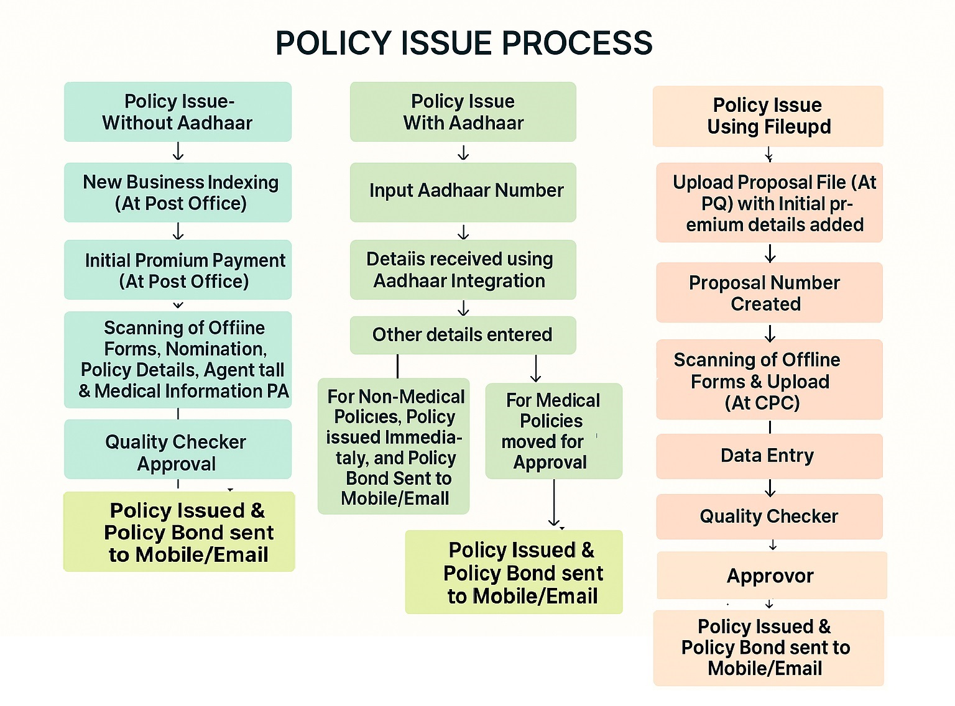

- Proposal Workflow Diagram Counter without Medical with Digilocker and Aadhar KYC: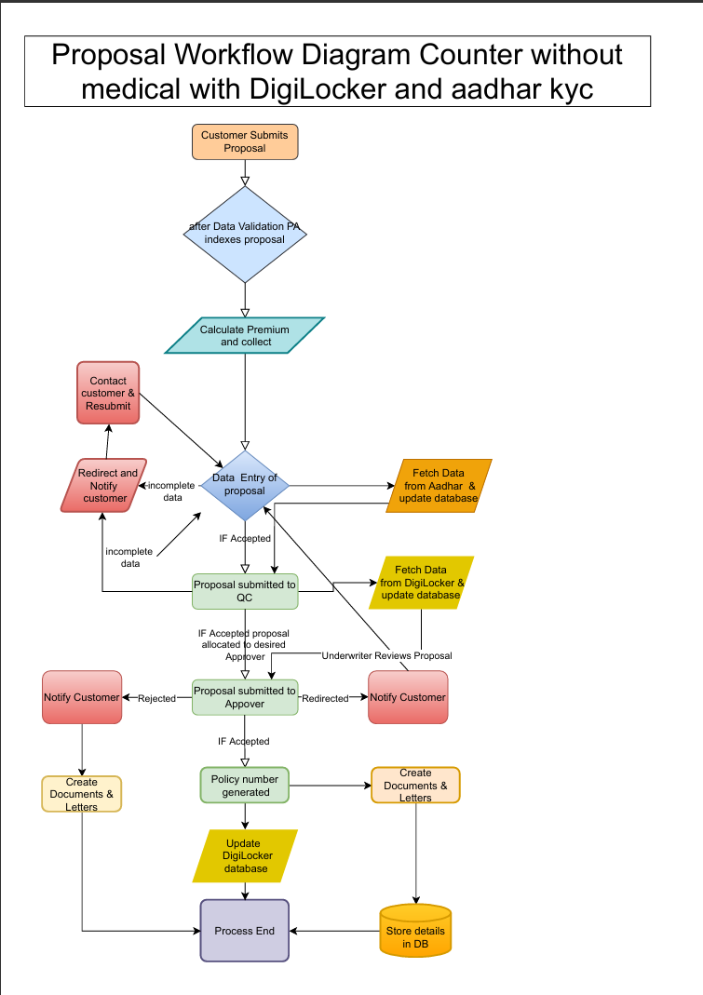

- Proposal workflow Diagram counter with Medical: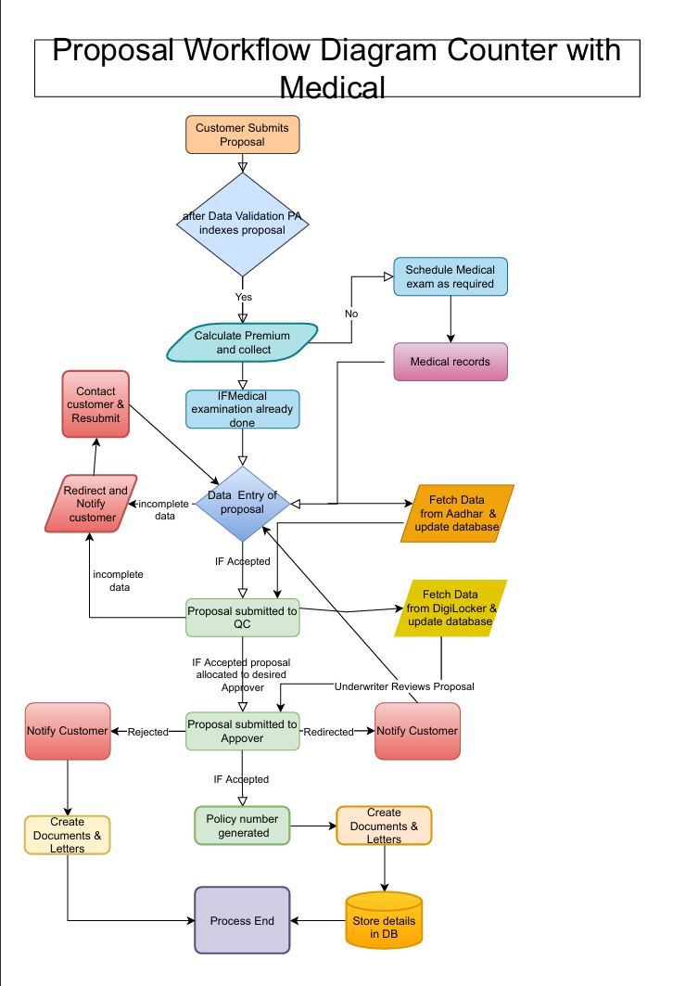

Policy Issue Cover Page:
- Fields:
  - Policy Issue- Without Aadhar: button
  - Policy Issue- With Aadhar: button

Policy Issue- Without Aadhar Page

    - Clicking ‘Policy Issue- Without Aadhar’ should open this page.
- Fields:
  - Creating New Application: button
  - Search for an Existing Application: button
- Business Rules:
  - Clicking ‘Creating New Application’ should move a user to ‘New Business Indexing Page’.
  - Clicking ‘Search for an Existing Application’ should move a user to ‘Search Existing Proposal’ page.
Process flow for Policy Issue Process of Customers who do not have Aadhar:
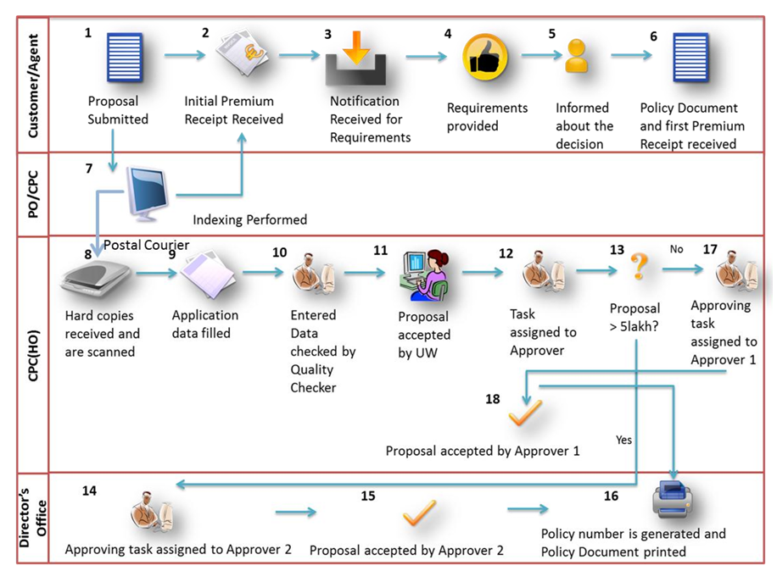

    - New Business Indexing Page.
- Fields:
  - Product Type: Dropdown: Contain PLI/RPLI
  - Product Name: Dropdown: Contain list of all products for PLI/RPLI as selected above in Product Type dropdown.
  - Product Description: Non-editable Text box with pre-filled details
  - Application Receipt Date: Date Field
  - Date of Proposal: Date Field
  - Date of Declaration: Date Field
  - Date of Indexing: Date Field
  - PO Code: Text box
  - First Name: Text box
  - Middle Name: Text box
  - Last Name: Text box
  - Date of Birth: Date Field
  - Gender: Dropdown with Male, Female, Other as option.
  - Opportunity ID: Text box
  - Issue Circle: Dropdown
  - Issue HO: Dropdown
  - Issue Post Office: Dropdown
  - Sum Assured: Text Box
  - Premium Ceasing Age: Dropdown
  - Premium Payment Frequency: Dropdown
  - Calculate Premium: Button
  - Premium Amount: Non-Editable field to display premium after Calculate premium button is pressed.
  - Submit: button
  - Previous: button
- Business Rules:
- After clicking submit, the following page should display:
  - Proposal Number: Non-Editable text box with pre-filled proposal Number.
  - Print Customer Acknowledgement Slip.: button: Clicking should generate the receipt.
  - Pay Premium: button: Clicking should open Premium Collection page.
  - New Indexing: button: Clicking should Open New Proposal Indexing page.

Serial# | Error Message | Required Action
1 | Date of declaration later than Date of Indexing | Users must carefully check the date of declaration, the date of receipt of application, the date of indexing, and the date of Proposal. These activities happen in the following sequence:  - Declaration signed by customer  - Application received  - Indexing performed for an application Proposal generated  Hence, the date of declaration will always be earlier than the date of receipt of application and the date of indexing. Similarly, the date of receipt of application will always be earlier than the date of indexing.  The date of proposal will always be later than all of the above dates.
2 | Date of declaration later than Application Receipt date
3 | Date of Proposal later than Date of Indexing
4 | Date of Proposal later than Date of Declaration
5 | Date of Proposal later than Application Receipt date
6 | Application Receipt date later than Date of Indexing

    - Search Existing Proposal Page.
- Fields:
  - Proposal Number: Text box
  - Fetch: button
- Business Rules:
  - Clicking ‘Fetch’ should open the searched proposal.

    - ‘Search Ticket Page’ for CPC User to search for Proposal/Policies.
- Fields:
  - Request Queue: Dropdown:
  - Stage Date Range: To and From Date field
  - Operation Center: Dropdown
  - Status: Dropdown
  - Proposal Number: Text box
  - Product: Dropdown
  - Request Type: Dropdown
  - Policy Number: Text Box
  - Search: button
- Business Rules:
  - Clicking ‘Search’ should Display the following:
    - Ticket ID: Non-Editable text
    - Customer ID: Non-Editable text
    - Policy No./Proposal No.: Non-Editable text
    - Request Type: Non-Editable text
    - Status: Non-Editable text
    - Request Date/Time: Non-Editable text
    - Request Owner: Non-Editable text
    - Indexed By: Non-Editable text
    - Office: Non-Editable text
    - Actions: button: Link to open the proposal
  - The opened proposal should contain the following pages:
    - Insured Details Page
    - Nomination Page
    - Policy Details Page
    - Agent Details Page
    - Medical Information Page

    - Insured Details Page.
- Fields:
  - Salutation
  - First Name
  - Middle Name
  - Last Name
  - Gender
  - Marital Status
  - Father’s Name
  - Husband Name
  - Date of Birth
  - Age Proof
  - Aadhar ID
  - Nationality
  - Communication Address:
    - Address Line1
    - Address Line2
    - Village
    - Taluka
    - City
    - District
    - State
    - Country
    - Pin Code
  - Permanent Address Same as Communication Address: Checkbox: Default is Checked. If Unchecked, the following fields should display:
    - Permanent Address:
      - Address Line1
      - Address Line2
      - Village
      - Taluka
      - City
      - District
      - State
      - Country
      - Pin Code
  - Contact Details:
  - Contact Type: Resident/Official
    - Area/STD Code
    - Landline Number
  - Mobile Number
  - Email
  - Insured and Proposer are Same: Checkbox: Default is Checked
  - Employment Details: Checkbox: Default is Unchecked
    - If ‘Employment Details’ Checkbox is Checked by the user, display the following fields:
      - Occupation
      - PAO/DDO Code
      - Organization
      - Designation
      - Date of entry in service
      - Designation of immediate superior
      - PAN Number
      - Monthly Income
      - Employer Address
        - Address Line1
        - Address Line2
        - Village
        - Taluka
        - City
        - District
        - State
        - Country
        - Pin Code
        - Official Phone Number
        - Official Email
      - Qualification
  - Add Spouse: Button: Option present only for Yugal Suraksha to add all the above details for Spouse also.
  - Subsequent Payment Method: dropdown: Options are Cash, Online, NACH, etc.
  - Bank Account Number for Payout: Text: For Payout during Maturity, Claim, etc.
  - IFSC Code: Text: For Payout during Maturity, Claim, etc.
  - If Insured is Married Female, display additional below fields:
    - Number of Children: Textbox
    - Date of Last Delivery: Calendar
    - If pregnant, then expected month of delivery: Dropdown: Options is number 1 to 9.
    - Mark of Identification-1: Textbox
    - Mark of Identification -2: Textbox
  - In Case of Children Policy, Add below fields:
    - Mother’s Name: Textbox
    - Parent’s Policy Number: Option to search the policy and select should be present.

- Business Rules:
  - ‘Insured and Proposer are Same’ should be checked by Default.
  - If ‘Insured and Proposer are Same’ is checked (Default), do not display any more fields and use the same data given for insured to store in proposer details tables also.
  - If ‘Insured and Proposer are Same’ is unchecked, display all the fields of Insured section again to be inputted for the proposer including Name, Gender, Marital Status, Father’s Name, Husband Name, Date of Birth, Age Proof, Aadhar ID, Nationality, Communication Address, Present Address, Contact Details, Mobile and Email.
  - If ‘Employment Details’ Checkbox is Checked by the user, then only, display the employment related fields. By, Default, this field should be unchecked.
Serial# | Error Message | Required Action
1 | Missing Spouse details | In Yugal Suraksha proposal, spouse details (first name/date of birth/gender) are to be provided. Enter appropriate spouse details.
2 | Missing Insured Husband’s Name | Provide the name of the husband if the insured is a married female.
3 | Missing Insured Father's Name | Provide the name of the father if the insured is a male or an unmarried female.
4 | Missing Insured Communication Address | This error message is displayed if all the fields or address 1st line from the communication address is missing. Users must enter appropriate information in all the fields in the Communication Address section.
5 | Missing Insured Permanent Address | This error message is displayed if all the fields or address 1st line from the permanent address is missing. Users must enter appropriate information in all the fields in the Permanent Address section.
6 | Missing Proposer Relationship with Insured | This message is displayed if the relationship of the insured and the proposer is not entered. Users must refer to the application form and enter this information.
7 | Missing Proposer Husband's name | This message is displayed if the proposer is married female and husband’s name is not entered on the screen. Users must enter the Husband’s name.
8 | Missing Proposer Father's Name | This message is displayed if the proposer is male or unmarried female and the father’s name is not entered on the screen. Users must enter the father’s name.
9 | Missing City or Village – Proposer address | Users must enter the name of either the city or the village of the proposer.
10 | Missing Date of Entry | This message is displayed if the date on which an insured joined his/her current organization has not been entered. Users must enter the appropriate date of joining.
11 | Missing Declaration date | If the declaration date is not provided or has been deleted.
12 | Missing Application receipt date | If the Application receipt date is not provided or has been deleted.
13 | Missing Policy Taken under | Is none of the radio buttons (HUF/MWPA/Others) has been selected.

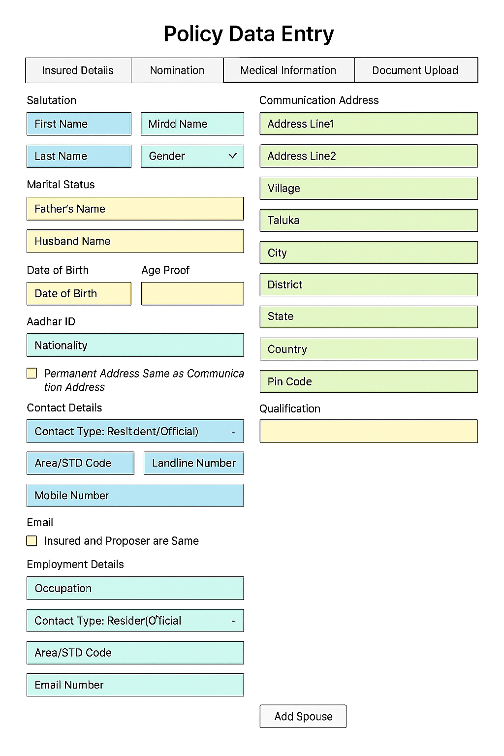

    - Nomination Page.
- Fields:
  - Add Nominee: button
    - Clicking of ‘Add Nominee’ button should lead to display of following input fields:
      - Salutation
      - First Name
      - Middle Name
      - Last Name
      - Gender
      - Date of Birth
      - Relationship: Dropdown
      - Share Percentage: Text box
      - Address:
        - Address Line1
        - Address Line2
        - Village
        - Taluka
        - City
        - District
        - State
        - Country
        - Pin Code
      - Phone Number/Mobile
      - Email Address
- Business Rules:
  - At max, 3 nominee addition is allowed.
  - Sum of input given in ‘Share Percentage’ field for all the added nominees should be 100%.
  - Nomination is mandatory if HUF, MWPA is not selected.
Serial# | Error Message | Required Action
1 | Missing Nominee Relationship | If the relationship of the nominee with the insured has not been provided. Users need to specify the relationship.
2 | Missing Nominee share percentage | If the share percentage of the sum assured to be received by various nominees has not been provided. Users need to enter the share percentage.

    - Policy Details Page.
- Fields:
Policy Information Section:
  - Application Declaration Date
  - Date of Acceptance
  - Issue Post Office
  - Application Receipt date
  - Date of Commencement of Risk
  - Policy Taken Under: Dropdown: HUF/MWPA/Other: If Other, display Textbox.
    - If MWPA is Selected as option for ‘Policy Taken Under’ dropdown, Display the Following additional fields:
      - Do you want to appoint a Trustee for Policy issued under the Married Women’s Property Act, 1874? : Dropdown: Options are Yes, No.
        - If Yes is Selected, Display the following additional fields:
          - Trust Type: Dropdown: Options are Individual, Corporate
          - Trust/Trustee Name: Textbox
          - Trustee Date of Birth: Calendar
          - Trustee Relationship: Textbox
          - Trustee Address: Textbox
    - If HUF is Selected as option for ‘Policy Taken Under’ dropdown, display the following additional fields:
      - Is this Insurance policy financed under HUF Funds?: Dropdown: Options are Yes, No
      - Full Name of Karta: Textbox
      - PAN Card Number for HUF: Textbox
      - Is Life assured is different from the Karta, please provide the reason as why Karta is not proposing Insurance on his own Life. : Dropdown: Options are Yes, No
        - If Yes is selected, display the following:
          - Reason: Textbox: Mandatory if Yes is selected
      - Add HUF Member: button: Option to Details of Co- Parceners/Members of HUF.
        - If ‘Add HUF Member’ button is clicked, display the option to add HUF Member by asking the following:
          - Member Name: Textbox
          - Member Relationship: Textbox
          - Member Age: Textbox
        - Option should be given to add at max 7 Members.

Additional Questions Section:
  - Does the proponent presently hold any PLI/RPLI Insurance policy? : Dropdown: (Yes/No): If Answer is yes, give option to add policy details.
  - Does the proponent presently hold any Non PLI/RPLI Insurance policy? : Dropdown: (Yes/No): If Answer is yes, give option to add policy details.
  - Does the proponent presently hold life insurance/health & non-life insurance policies of other companies? : Dropdown: (Yes/No): If Answer is yes, give option to add policy details

Base Coverage Section: Auto-Populate
  - Policy Type
  - Premium Ceasing Age
  - Sum Assured
  - Medical
  - Coverage Age

Premium Information Section:
  - Annual Premium Equivalent
  - Premium- Initial
  - Additional Premium
  - Premium Payment Method
  - Subsequent Premium Payment Mode
  - Premium Payment Frequency
  - Modal Premium
  - Premium Payable
  - Short/Excess Premium
- Business Rules:

    - Agent Details Page.
- Fields:
  - Proposal Without Agent- Checkbox-Default is Checked. Below displays will be displayed only if this checkbox is checked.
    - Agent ID: Text box
    - Search Agent: button: To search and select the Agent from existing database.
    - Receives Correspondence- Radiobutton: Yes/No
    - Salutation
    - First Name
    - Middle Name
    - Last Name
    - Opportunity ID
    - Area/STD Code
    - Landline Number
    - Mobile Number
    - Email Address
- Business Rules:

    - Medical Information Page- General
- Fields:
  - Are you in Sound Health at Present? Dropdowns: Yes/No: Default-Yes
  - Have you ever suffered/suffering from any of the following
    - Tuberculosis: Checkbox: Default- Unchecked
    - Cancer: Checkbox: Default- Unchecked
    - Paralysis: Checkbox: Default- Unchecked
    - Insanity: Checkbox: Default- Unchecked
    - Any disease of heart and lungs: Checkbox: Default- Unchecked
    - Kidney Disease: Checkbox: Default- Unchecked
    - Any Disease of Brain: Checkbox: Default- Unchecked
    - HIV Positive: Checkbox: Default- Unchecked
    - Hepatitis-B: Checkbox: Default- Unchecked
    - Epilepsy: Checkbox: Default- Unchecked
    - Nervous Disorder: Checkbox: Default- Unchecked
    - Liver: Checkbox: Default- Unchecked
    - Leprosy: Checkbox: Default- Unchecked
    - Any Physical Deformity or Handicap: Checkbox: Default- Unchecked
    - Any other serious disease: Checkbox: Default- Unchecked
  - Details of Disease- Text box to be filled if disease Exist
  - Has any of your family members living or dead suffered from any hereditary or infectious disease like Insanity/Epilepsy/Gout/Asthma/Tuberculosis/Cancer/Leprosy, etc.? : Dropdown: Yes/No: Default is No
    - If Yes, Give Details
  - Have you availed any kind of leave on medical ground or hospitalized during the last 3 years?: Dropdown: Yes/No: Default: No
    - If Yes, Give Details of:
    - Kind of Leave
    - Period of Leave
    - Ailment
    - Name of Hospital
    - Period of Hospitalization:
    - From
    - To
  - Do you have any physical deformity or congenital by birth defects?: Dropdown: Yes/No: Default: No. The below options will display only if this dropdown is set to Yes.
    - Congenital: Checkbox: Default- Unchecked
    - Non-Congenital: Checkbox: Default- Unchecked
    - Congenital/Non-Congenital: Checkbox: Default- Unchecked
  - Particulars of Family Doctor, If any
    - Doctor Name
  - Accepted: button
- Business Rules:
  - Add two checkboxes in each for Yugal Suraksha Policy with default options selected.

    - Medical Information Page- Policy Greater than 20 Lakh Sum Assured.

- Fields:
Additional Health Details Needed if Sum Assured is greater than 20 Lakhs:
- Are you currently undergoing/have undergone any tests, investigations, awaiting results of any tests, investigation or have you ever been advised to undergo any tests, investigations or surgery or been hospitalised for general check-up, observations, treatment or surgery : Dropdown: Yes/No: Default is No
- Diabetes/ High Blood Sugar : Dropdown: Yes/No: Default is No
- High/ Low Blood Pressure : Dropdown: Yes/No: Default is No
- Have you ever been referred to an : Oncologist or cancer hospital for any investigation or treatment : Dropdown: Yes/No: Default is No
- Did you have any ailment/injury/accident requiring treatment//medication for more than a week : Dropdown: Yes/No: Default is No
- Have you ever suffered Thyroid disorder or any other disease or disorder of the endocrine system : Dropdown: Yes/No: Default is No
- (vii) Ave you undergone/have been recommended to undergo Angioplasty , bypass surgery, brain surgery, Heart valve surgery Aorta surgery or organ transplant : Dropdown: Yes/No: Default is No
- Have you ever suffered disorders of eye, ear, nose, throat, including defective sight speech or hearing & discharge from ears : Dropdown: Yes/No: Default is No
- Have you ever suffered Anaemia, blood or blood related disorders : Dropdown: Yes/No: Default is No
- Have you ever suffered musculoskeletal disorders such as arthritis, recurrent back pain, slipped disc or any other disorder of spine, joints, limbs or leprosy : Dropdown: Yes/No: Default is No

Additional Health Information for Female Proponent (In case of Sum Assured or Aggregate Sum Assured exceeding 20 lakh)
    - Have you ever have any abortion, miscarriage or ectopic pregnancy : Dropdown: Yes/No: Default is No
    - Have you ever undergone any gynaecological investigations, internal checkups, breast checkups such as mammogram or biopsy : Dropdown: Yes/No: Default is No
    - Have you ever consulted a Doctor because of an irregularity at the breast, vagina, uterus, ovary, fallopian tubes, menstruation, birth delivery, complications during pregnancy or child delivery or a sexually transmitted diseases? : Dropdown: Yes/No: Default is No

Personal habits of the proponent impacting health (Required in case of Sum Assured/ Aggregate Sum Assured is above `20 lakh)
If Yes, Whether Frequently or Occasionally
- Do you Smoke/ Consume Tobacco? : Dropdown: Yes/No, If Yes, display one more dropdown asking whether Frequently or Occasionally. : Default is No.
- Do you Consume Alcohol? : Dropdown: Yes/No, If Yes, display one more dropdown asking whether Frequently or Occasionally. : Default is No.
- Do you Consume Drugs? : Dropdown: Yes/No, If Yes, display one more dropdown asking whether Frequently or Occasionally. : Default is No.
- Do you have any habits, which can adversely impact your health? : Dropdown: Yes/No, If Yes, display one more dropdown asking whether Frequently or Occasionally. : Default is No.

- Business Rules:
  - ‘Medical Information Page- Policy Greater than 20 Lakh Sum Assured’ page should display only if Sum Assured selected by the insured is greater than or equal to 20 Lakh.
  - Add two checkboxes in each for Yugal Suraksha Policy with default options selected.

    - Document Upload Page.
- Fields:
  - Add Document: button
  - Attached Existing Document: Table
  - Download: button
  - Delete Document: button
- Business Rules:
  - Existing Scanned Document should get uploaded in this page.
  - The page should have option to upload the documents.
  - The page should have option to download the documents.
  - The page should have option to delete the documents.
  - Each document should be versioned and comment note should be added for each of the documents.

    - Approval Page.
- Fields:
  - Approval: Dropdown: Options include Approve, Reject.
  - Submit: button
- Business Rules:
  - Quality Reviewer and Approver both should be able to approve the Proposal.
  - Policy Number should get generated only after the approval of Approver.
  - Upon Rejection, User should input the comments for Rejection.
- Levels of Approval: There are three levels of Approvers in the system:
  - Approver 1: They can approve proposals with Sum Assured (SA) value less than or equal to 500000.
  - Approver 2: They approve proposals with sum assured value more than 500000 and less than 1000000.
  - Approver 3: They approve proposals with sum assured value more than 1000000.

Policy Issue- With Aadhar Page

    - Clicking ‘Policy Issue- With Aadhar’ should open this page.
- Fields:
  - Aadhar Number: textbox
  - Submit: button
- Business Rules:
  - Aadhar Integration should happen in such a way that clicking submit button should fetch the following details automatically from Aadhar:
    - Full Name
    - Date of Birth
    - Gender
    - Address
    - Photograph (Base64 image)
    - Email (if linked)
    - Mobile Number
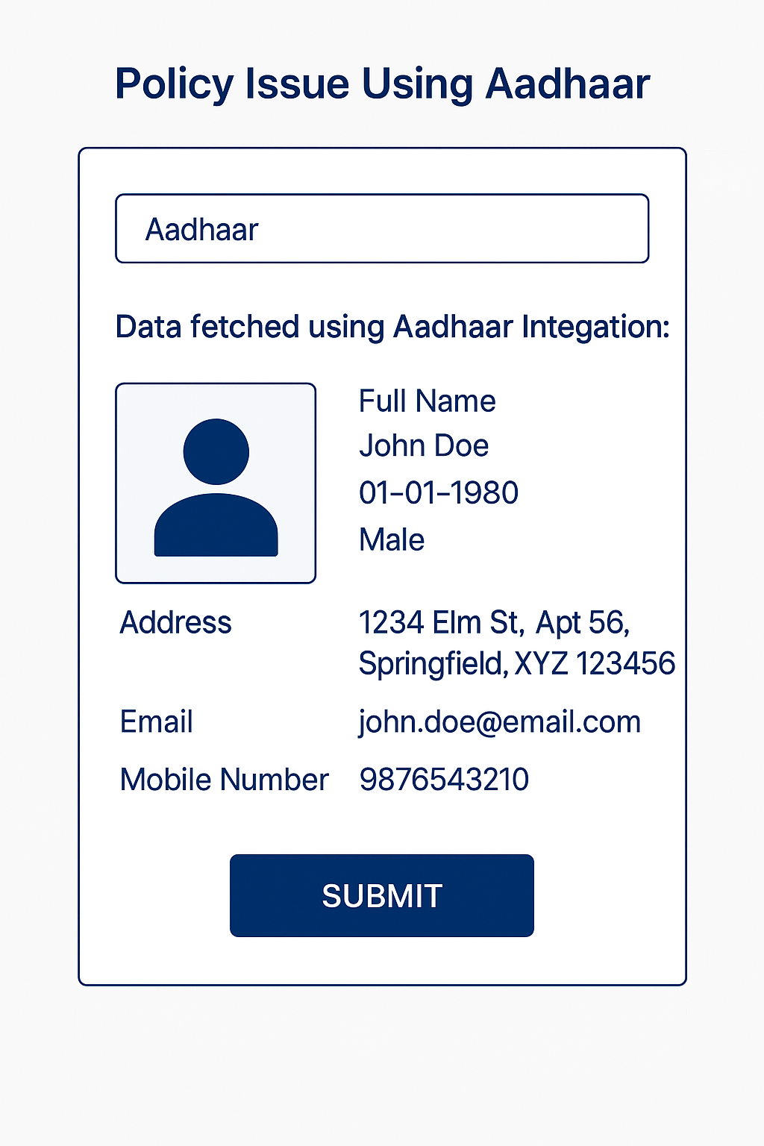
    - User Input page.
- Fields:
  - PAN: Textbox
  - Product Type: Dropdown: PLI/RPLI
  - Product Name: Dropdown
  - Premium Ceasing Age/Term
  - Sum Assured
  - Premium Frequency
  - Subsequent Premium Payment Mode
  - Add Nominee: button
    - If Add Nominee button is clicked, display the following to be added:
      - Salutation
      - First Name
      - Middle Name
      - Last Name
      - Gender
      - Date of Birth
      - Relationship: Dropdown
      - Share Percentage: Text box
      - Address:
        - Address Line1
        - Address Line2
        - Village
        - Taluka
        - City
        - District
        - State
        - Country
        - Pin Code
      - Phone Number/Mobile
      - Email Address
  - Father's/Husband's Name: Text box
  - Marital Status
  - Add Employer: button
    - If Add Employer button is clicked, display the following fields for adding employer details:
      - Occupation
      - PAO Code
      - Organization
      - Designation
      - Date of entry in service
      - Designation of immediate supervisor
      - PAN Number
      - Monthly Income
      - Employer Address
        - Address Line1
        - Address Line2
        - Village
        - Taluka
        - City
        - District
        - State
        - Country
        - Pin Code
        - Official Phone Number
        - Official Email
      - Qualification
  - Mobile Number: Text box: Input the Aadhar fetched mobile number by default
  - Email: Text box: Input the Aadhar fetched Email by default
  - Agent ID: Text box
  - Policy Taken Under: Dropdown: HUF/MWPA/Other: If Other, display Textbox.
    - If MWPA is Selected as option for ‘Policy Taken Under’ dropdown, Display the Following additional fields:
      - Do you want to appoint a Trustee for Policy issued under the Married Women’s Property Act, 1874? : Dropdown: Options are Yes, No.
        - If Yes is Selected, Display the following additional fields:
          - Trust Type: Dropdown: Options are Individual, Corporate
          - Trust/Trustee Name: Textbox
          - Trustee Date of Birth: Calendar
          - Trustee Relationship: Textbox
          - Trustee Address: Textbox
    - If HUF is Selected as option for ‘Policy Taken Under’ dropdown, display the following additional fields:
      - Is this Insurance policy financed under HUF Funds?: Dropdown: Options are Yes, No
      - Full Name of Karta: Textbox
      - PAN Card Number for HUF: Textbox
      - Is Life assured is different from the Karta, please provide the reason as why Karta is not proposing Insurance on his own Life. : Dropdown: Options are Yes, No
        - If Yes is selected, display the following:
          - Reason: Textbox: Mandatory if Yes is selected
      - Add HUF Member: button: Option to Details of Co- Parceners/Members of HUF.
        - If ‘Add HUF Member’ button is clicked, display the option to add HUF Member by asking the following:
          - Member Name: Textbox
          - Member Relationship: Textbox
          - Member Age: Textbox
        - Option should be given to add at max 7 Members.
  - Medical Information: (Separate Popup for user to confirm with default options selected): Popup should contain details as per section 4.1.9 and 4.1.10 (Sum Assured Greater than 10 lakh).
  - Add Spouse: Button: Option present only for Yugal Suraksha to add all the above details for Spouse also.
  - Subsequent Payment Method: dropdown: Options are Cash, Online, NACH, etc.
  - Bank Account Number for Payout: Text: For Payout during Maturity, Claim, etc.
  - IFSC Code: Text: For Payout during Maturity, Claim, etc.
  - If Insured is Married Female, display additional below fields:
    - Number of Children: Textbox
    - Date of Last Delivery: Calendar
    - If pregnant, then expected month of delivery: Dropdown: Options is number 1 to 9.
    - Mark of Identification-1: Textbox
    - Mark of Identification -2: Textbox
  - In Case of Children Policy, Add below fields:
    - Mother’s Name: Textbox
    - Parent’s Policy Number: Option to search the policy and select should be present.
  - Calculate Premium: button
- Business Rules:
  - Clicking ‘Calculate Premium’ should display the premium details.
  - Option to Pay premium using Cash & Cheque (For Post office)/ Online modes should be present.
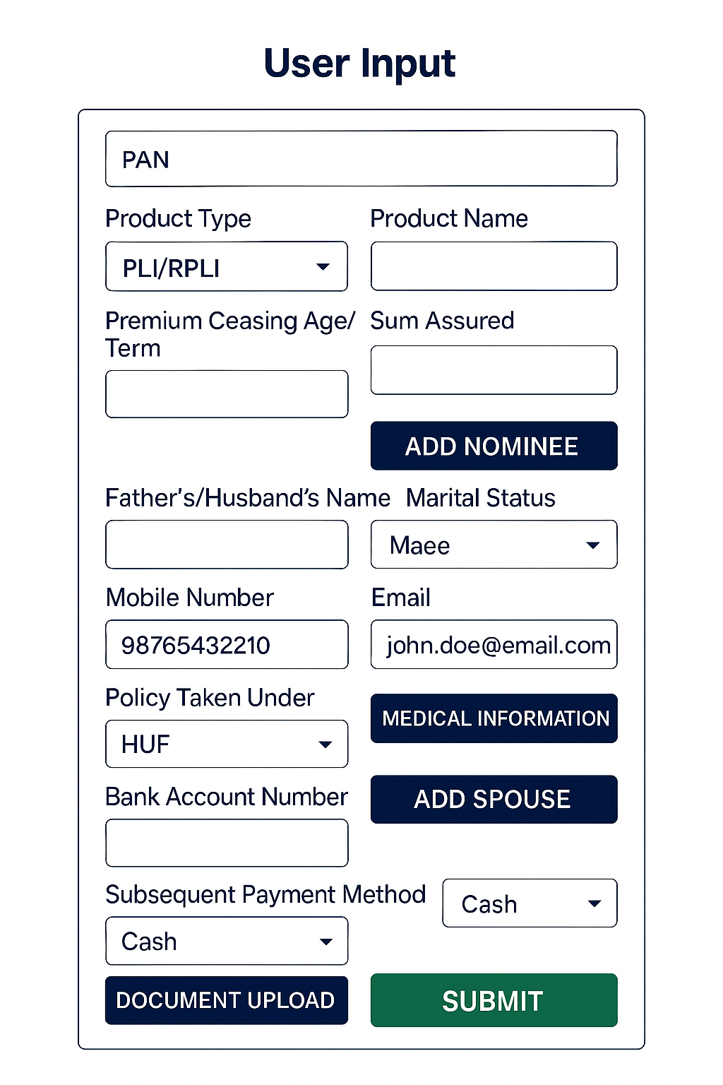

    - Document Upload page.
- Fields:
  - Add Document: button
  - Attached Existing Document: Table
  - Download: button
  - Delete Document: button

- Business Rules:
  - User should be able to upload the additional document needed.

    - Review and Submit page.
- Fields:
  - Policy Details: Table
  - Premium Information: Table
  - Uploaded Document List: Table
  - Submit: button
  - Cancel: button
- Business Rules:
  - Submitting the form should display the Proposal number.
  - CPC User should be able to open and Proceed with the proposal as per the established process.
  - The Policy Number should get generated automatically for the non-Medical Policies and Policy Bond should be sent to WhatsApp/Email for the Insured.

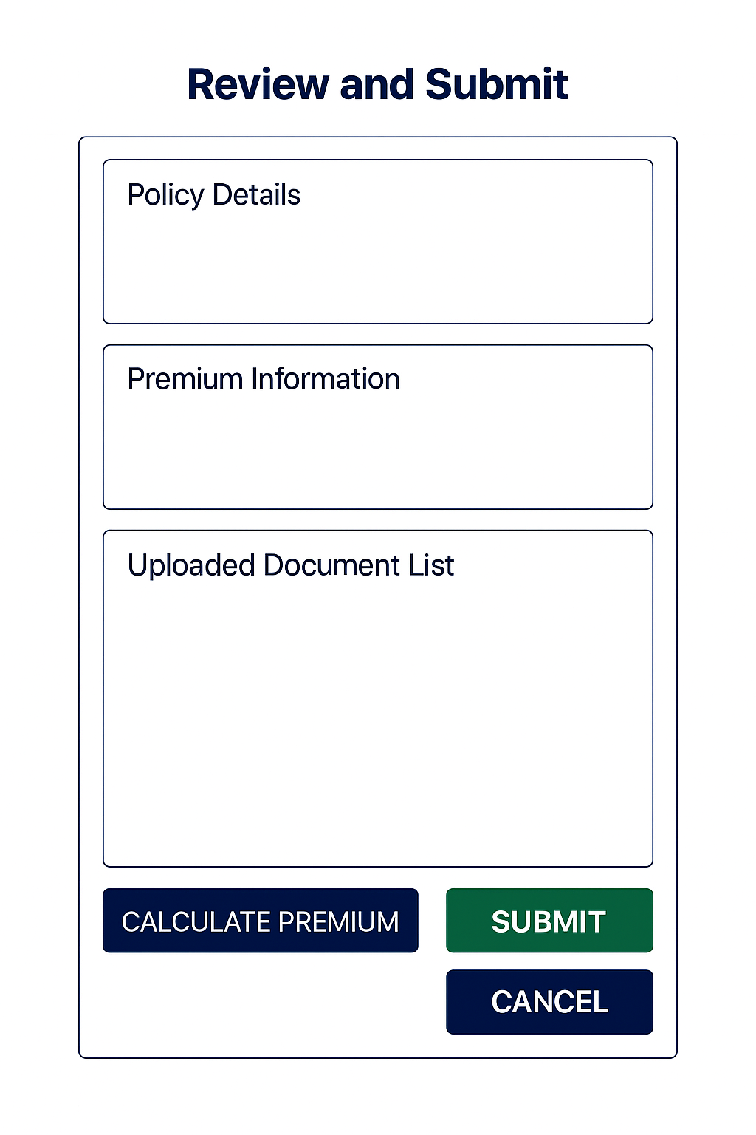

Proposal Creation- Using File Upload
Flow Diagram for the Policy Issue Process using File Upload:
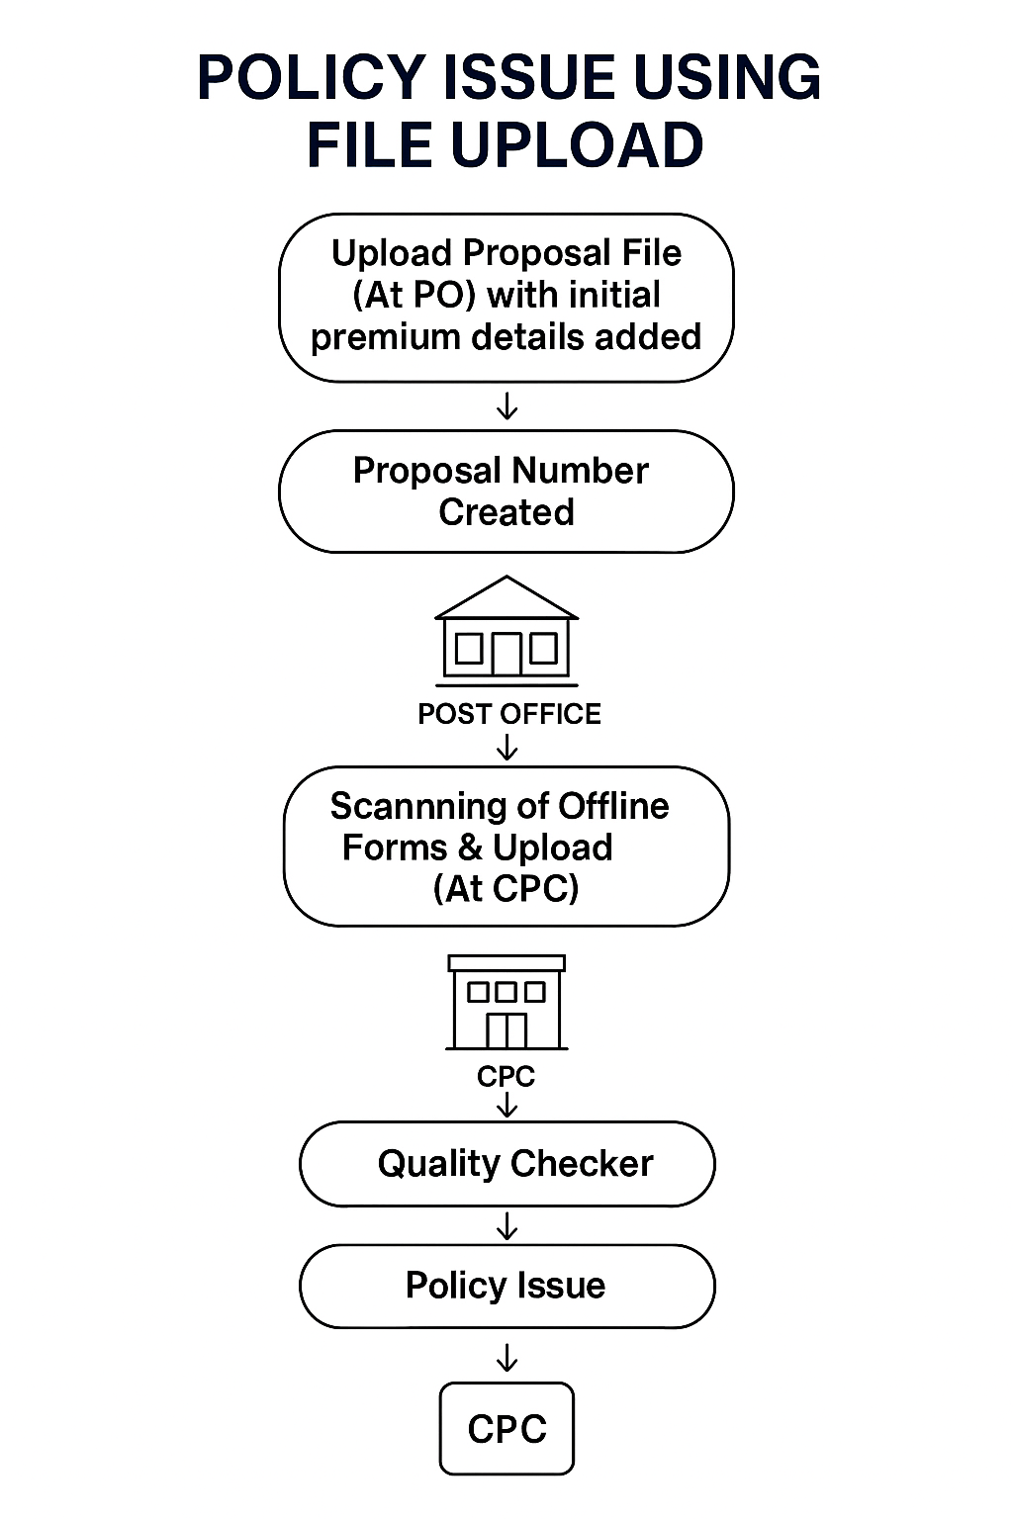
    - Proposal Creation Using File Upload Page.
- Fields:
  - Upload File: Excel/CSV file input
  - Download Template: Button to download the standard template
  - Instructions Panel: Guidelines for filling the template (e.g., mandatory fields, format rules)
  - Upload Button: To initiate file upload
  - Validation Summary: Display of success/failure count after upload
  - Error Report Download: Button to download error details for failed rows
- Business Rules:
  - Successfully Uploading the form should display the list of Proposal numbers in the Interface.
  - Option should be there in Interface to download the list of successful proposals with Proposal Number.
  - CPC User should be able to open and Proceed with the proposal as per the established process.

5. Wireframe

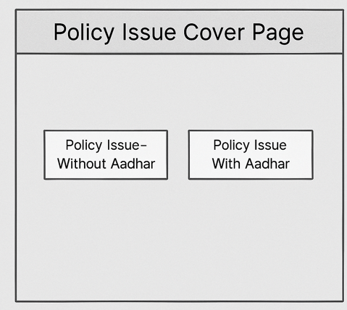

5.1 Policy Issue- without Aadhar Page
Fig-1: Insured Details Page for Proposal (CPC User View)

Fig-2: Policy Details Page:
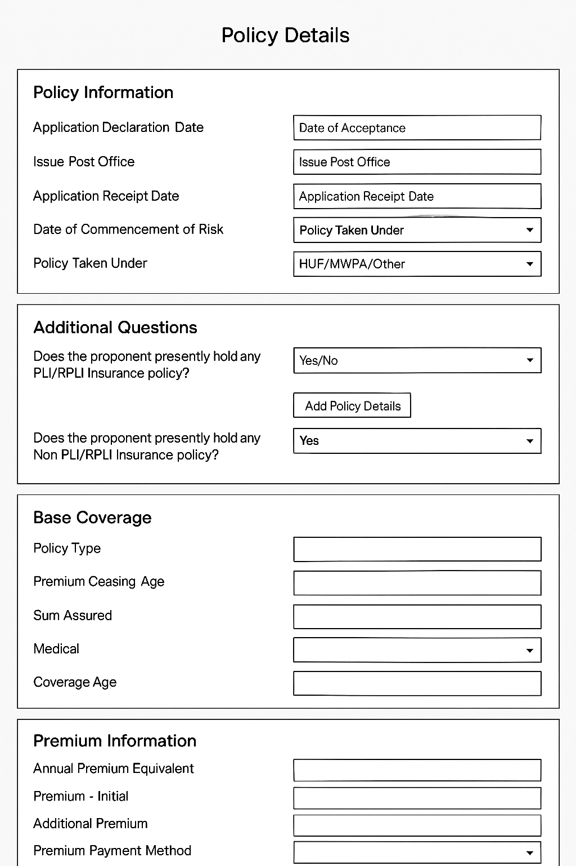

5.2 Policy Issue- with Aadhar Page
Fig-1: Input Aadhar and details will be automatically fetched.

Fig-2: User Input Page:

Fig-3: Document Upload Page
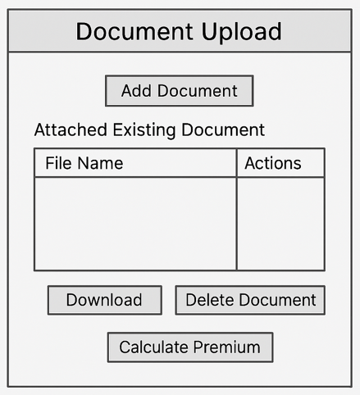
Fig-3: Review and Submit Page


5.3 Proposal Creation- Using File Upload

Fig-1: Proposal Creation using file upload. This option is for creation of Proposals in bulk which can be processed in CPC Later for policy issue. Payment, if done, using a combined cheque for multiple policy, the details of initial premium payment can be processed using this method.
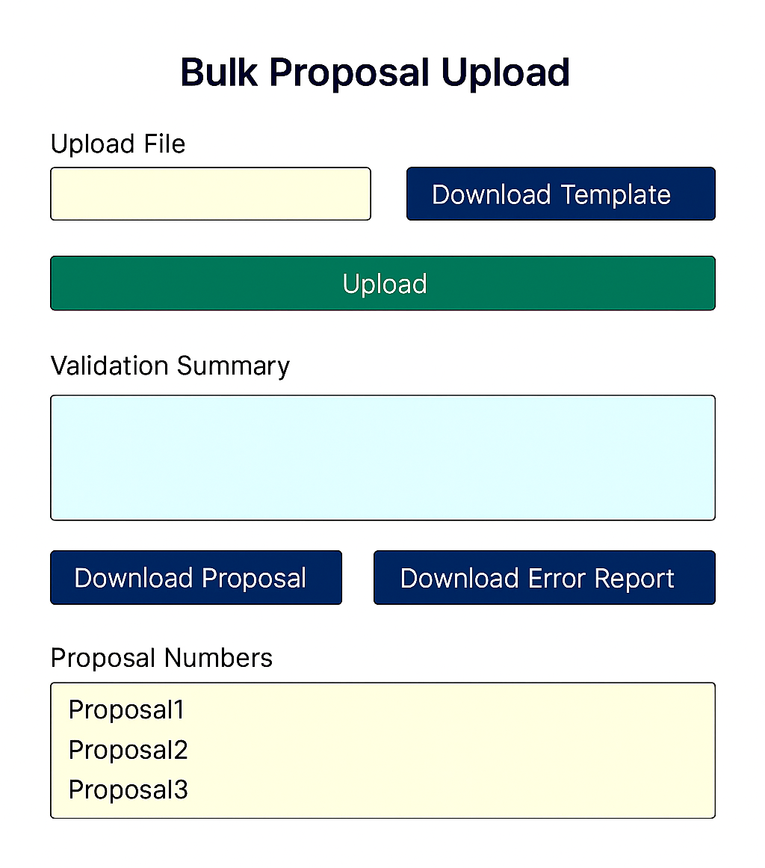

5. Test Case
The test case for the policy issue feature is given below:
Functionality | TC Number | Test Case Name | Detail Description | Expected Result
Policy Issue at PO | TC_NB_PO_001 | Index Docs | Verify successful indexing of proposal documents at PO | Documents indexed and visible to CPC
Policy Issue at PO | TC_NB_PO_002 | Retrieve Docs | Validate CPC can retrieve indexed documents | CPC retrieves documents without error
Policy Issue at PO | TC_NB_PO_003 | Mandatory Fields | Ensure mandatory fields captured correctly | All mandatory fields saved
Policy Issue at PO | TC_NB_PO_004 | Missing Fields | Missing mandatory fields during CPC entry | System shows validation error
Policy Issue at PO | TC_NB_PO_005 | Invalid DOB | Invalid date format for DOB | System rejects invalid date
Policy Issue at PO | TC_NB_PO_006 | Invalid Sum | Incorrect Sum Assured below/above limits | System shows error message
Policy Issue at PO | TC_NB_PO_007 | Duplicate Proposal | Duplicate proposal number entry | System prevents duplicate entry
Policy Issue at PO | TC_NB_PO_008 | Policy Number Gen | System auto-generates Policy Number | Policy number generated successfully
Policy Issue at PO | TC_NB_PO_009 | KYC Missing | Attempt to issue policy without KYC | System blocks issuance
Policy Issue at PO | TC_NB_PO_010 | Full Flow Success | Complete flow: Indexing at PO → CPC data entry → Policy issuance | Policy issued successfully with valid Policy Number
Digital Policy Issue for Non-Medical Policies | TC_NB_Aadhar_011 | Aadhaar Auth | Verify Aadhaar authentication for Non-Medical policy | Authentication successful
Digital Policy Issue for Non-Medical Policies | TC_NB_Aadhar_013 | Issue Policy | Validate successful policy issuance after Aadhaar verification | Policy issued successfully
Digital Policy Issue for Non-Medical Policies | TC_NB_Aadhar_014 | Auth Fail | Aadhaar authentication fails (invalid OTP) | System shows authentication error
Digital Policy Issue for Non-Medical Policies | TC_NB_Aadhar_015 | Details Mismatch | Aadhaar details mismatch with proposal | System rejects proposal
Digital Policy Issue for Non-Medical Policies | TC_NB_Aadhar_016 | Premium Calc | Validate premium calculation for Non-Medical policy | Premium calculated correctly
Digital Policy Issue for Non-Medical Policies | TC_NB_Aadhar_017 | Nominee Missing | Issue policy without nominee details | System shows error
Digital Policy Issue for Non-Medical Policies | TC_NB_Aadhar_018 | Age Restrict | Restrict Non-Medical policy for age > 50 | System blocks issuance
Digital Policy Issue for Non-Medical Policies | TC_NB_Aadhar_019 | Non-Medical Success | Aadhaar authentication, premium calculation, payment, and issuance | Policy issued successfully without medical certificate
Digital Policy Issue for Medical Policies | TC_NB_Aadhar_020 | Aadhaar Auth Med | Verify Aadhaar authentication for Medical policy | Authentication successful
Digital Policy Issue for Medical Policies | TC_NB_Aadhar_021 | Upload Cert | Validate medical certificate upload before issuance | Certificate uploaded successfully
Digital Policy Issue for Medical Policies | TC_NB_Aadhar_022 | Cert Missing | Missing medical certificate for required policy | System blocks issuance
Digital Policy Issue for Medical Policies | TC_NB_Aadhar_023 | Invalid File | Upload invalid file format for certificate | System rejects file
Digital Policy Issue for Medical Policies | TC_NB_Aadhar_024 | Premium Calc Med | Validate premium calculation based on medical status | Premium calculated correctly
Digital Policy Issue for Medical Policies | TC_NB_Aadhar_025 | No Approval | Issue policy without medical approval | System blocks issuance
Digital Policy Issue for Medical Policies | TC_NB_Aadhar_026 | Cert Expired | Medical certificate expired | System rejects certificate
Digital Policy Issue for Medical Policies | TC_NB_Aadhar_027 | Medical Success | Aadhaar authentication, medical certificate upload, approval, payment, and issuance | Policy issued successfully after medical approval
Bulk Proposal Issue | TC_NB_Bulk_028 | Upload File | Verify successful upload of bulk proposal file | File uploaded successfully
Bulk Proposal Issue | TC_NB_Bulk_029 | Process Proposals | Validate system processes all proposals | All proposals processed
Bulk Proposal Issue | TC_NB_Bulk_030 | Missing Columns | Upload file with missing mandatory columns | System shows error report
Bulk Proposal Issue | TC_NB_Bulk_031 | Invalid Data | Upload file with invalid data types | System rejects invalid rows
Bulk Proposal Issue | TC_NB_Bulk_032 | Error Report | Validate system generates error report for failed records | Error report generated
Bulk Proposal Issue | TC_NB_Bulk_033 | File Too Large | Upload file exceeding max size | System rejects file
Bulk Proposal Issue | TC_NB_Bulk_034 | Partial Success | Validate partial success scenario | Valid proposals processed, invalid ones reported
Bulk Proposal Issue | TC_NB_Bulk_035 | Bulk Success | Upload valid bulk file, process proposals, generate policies | All valid proposals converted to policies successfully

6. Appendices
The Following Documents attached below can be used.

